

**CARMARTHEN LIVESTOCK MART**

**WEEKLY REPORT – 09.11.22**



**170 CALVES**

*Auctioneer -Elwyn Thomas 07989850307*

Stronger calves forward resulting in a better trade for the grade 1 and 2 especially in the bull section.

Top at £385 for a Lim X from Evans Tandderi, BRB to £378 twice from Griffiths Llwyngwcw. Charolais were up to £272 from Beynon Glantowy with Herefords topping at £275.00 from Howells Posty Isaf.

Heifers, especially grade 2 calves were slightly down on previous weeks but with Blues topping at £238 from Griffiths Llwyngwcw and Lims to £230 from Davies Penlanffos.

Diolch am eich cefnogaeth!!

**TOP PRICES**

**BULLS**

£385.00 1m LIMX Evans Tandderi

£378.00 1m BRB Griffiths Llwyngwcw

£378.00 BRB 1m Griggiths LLwyngwcw

£330.00 BRB 1m Evans Tandderi

£315.00 LIMX 1m Davies Penlan Ffos

**HEIFERS**

£238.00 BRB 1m Griffiths Llwyngwcw

£230.00 LIMX 1m Davies Penlan Ffos

£215.00 BRB 1m FFGF LTD

£188.00 BRB 1m Griffiths Llwyngwcw

£168.00 BRB 1m Harries Gelli’r Odyn

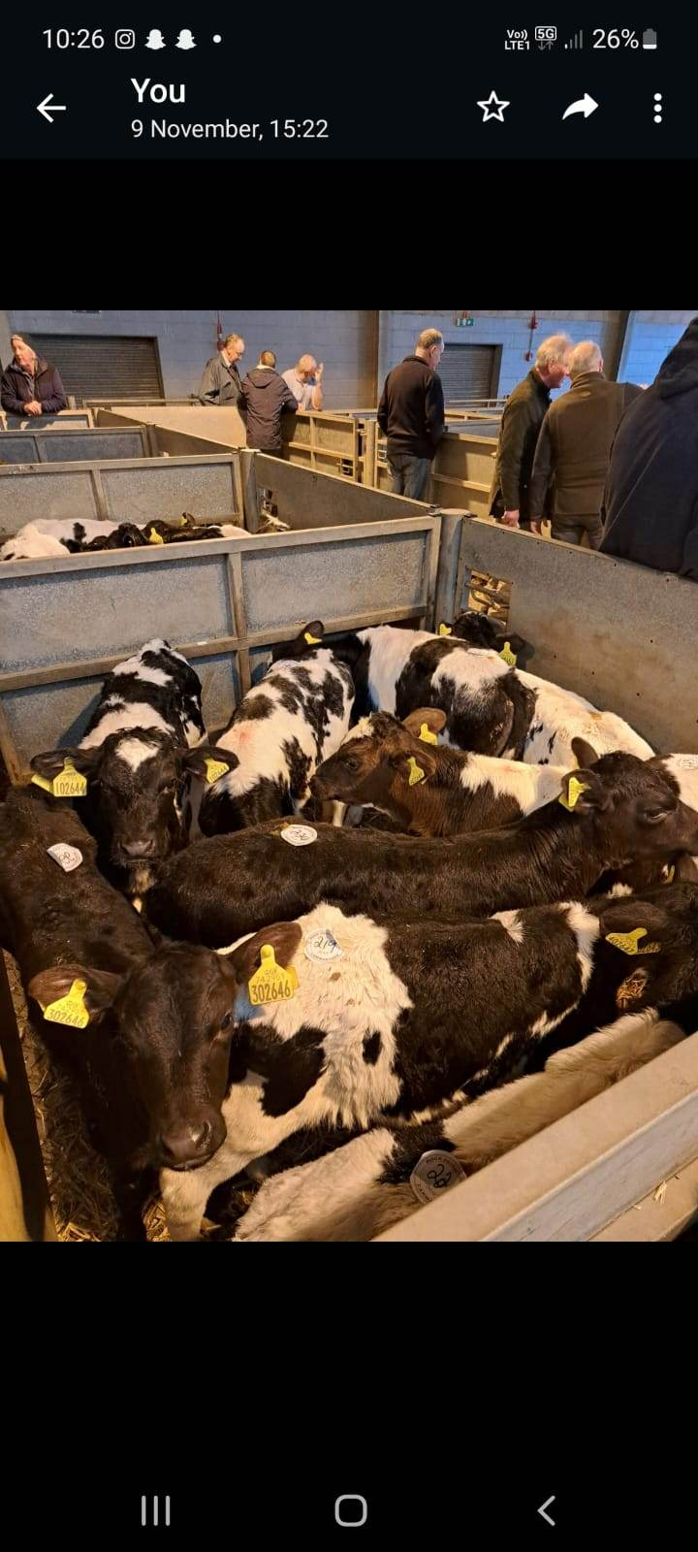

**SHOP UNIT TO RENT**

**CONTACT ROB McCABE 07970981183**



**NEXT WEANED & BREEDING CATTLE SALE**

**MONDAY 5TH OF DECEMBER**

**WHICH WILL INCLUDE CHRISTMAS PRIZE SALE**

**TOP PRIZE WEANED STEER (UNDER 12 MONTHS)**

**TOP PRIZE WEANED HEIFER (UNDER 12 MONTHS)**

**TOP PRIZE COW AND CALF**

**TOP PRIZE BREEDING BULL**

**TOP PRIZE GROUP OF WEANED CATTLE (3 OR MORE UNDER 12 MONTHS)**





**NEXT DATES**

**WEANED CALVES**

**SUCKLER COWS**

**BULLS**

**1ST Monday of each month**

**Next date: 5TH DECEMBER**

**TB ORANGE RESTRICTED**

**2ND Monday of each month**

**Next date 12th DECEMBER**

**To register your stock please contact the following:**

**Llŷr Jones: 07812934964**

**Paul Taylor: 07815509504**

**E-MAIL –** [**Carmarthenmart@nockdeighton.co.uk**](mailto:Carmarthenmart@nockdeighton.co.uk)

